Terraform

1. If you want to create a Virtual machine, app service, VNet, SQL Database and if you want to do all these things via script, we can do it by using terraform
2. ARM template is dedicated to Microsoft Azure only however the terraform can be used in Azure as well as AWS and ON premises network (Private Cloud)
3. Microsoft has Azure stack which is on premises of Azure
4. Open stack is the on-premises implementation of open cloud which will supports terraform
5. Using terraform gives us the benefit of using scripts which you can work on premises as well as in cloud environment
6. In terraform we are going to get a execution plan and that is going to describe and that is going to describe what we need to do to reach the desired state
7. In ARM template we are going to use resource section and under each resource we are going to use Json file
8. In terraform also we are going to use terraform script that we need to specify the resources
9. We will write the code in Hashicorp Language (HCL) but we can express the terraform using Json files also
10. This is declarative program (HCL and json) whereas for C# is imperative program

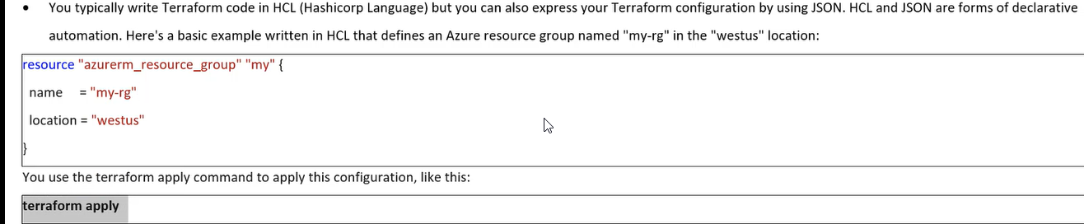

1. Once we have created the resource, we can do terraform apply before that we need to build the terraform environment

How terraform files are structured

1. Main file in terraform is main.tf file preferably we can use main, but we can we give another name
2. Main.tf is called terraform plan
3. In main.tf we are going to give all required information

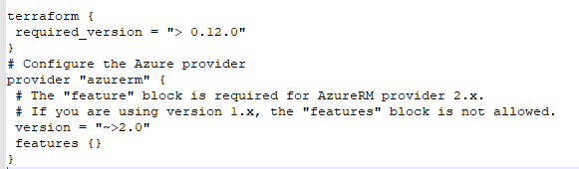

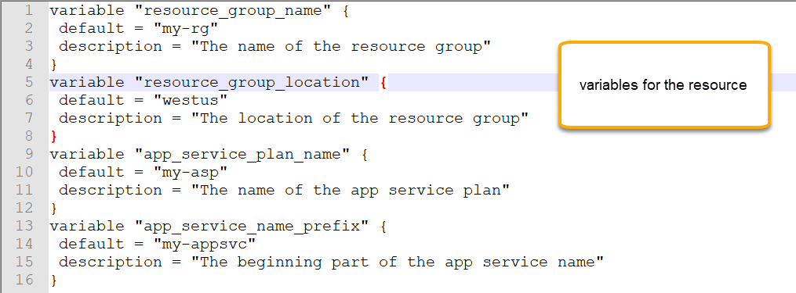

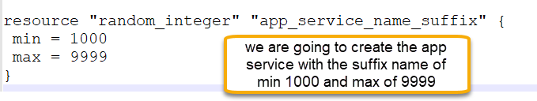

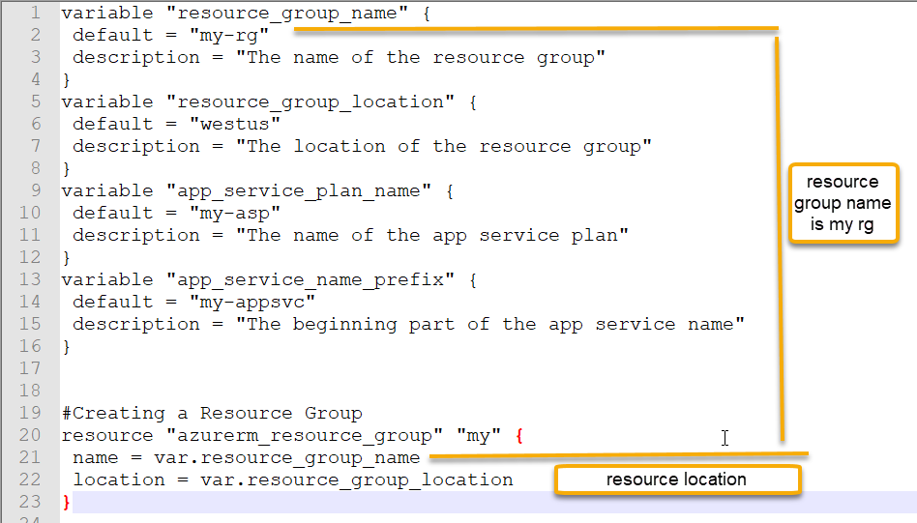

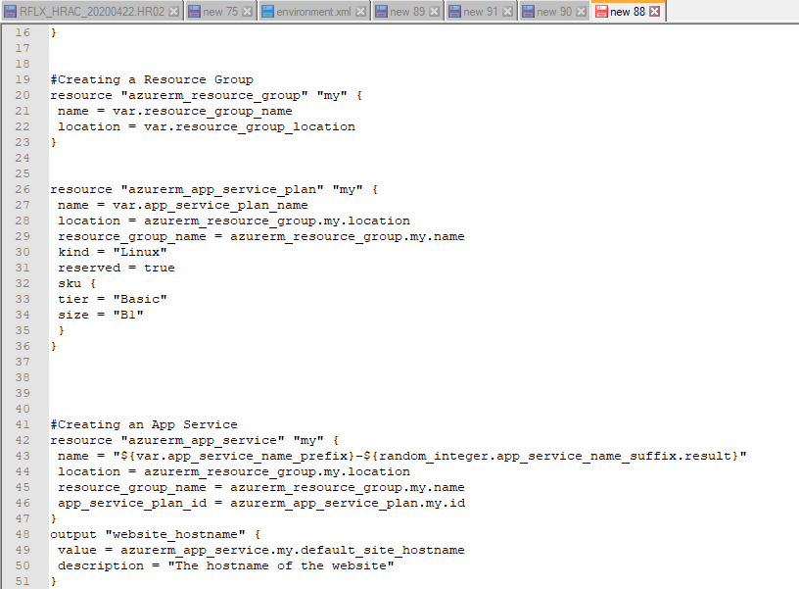

Now copy the code and paste it in the new folder

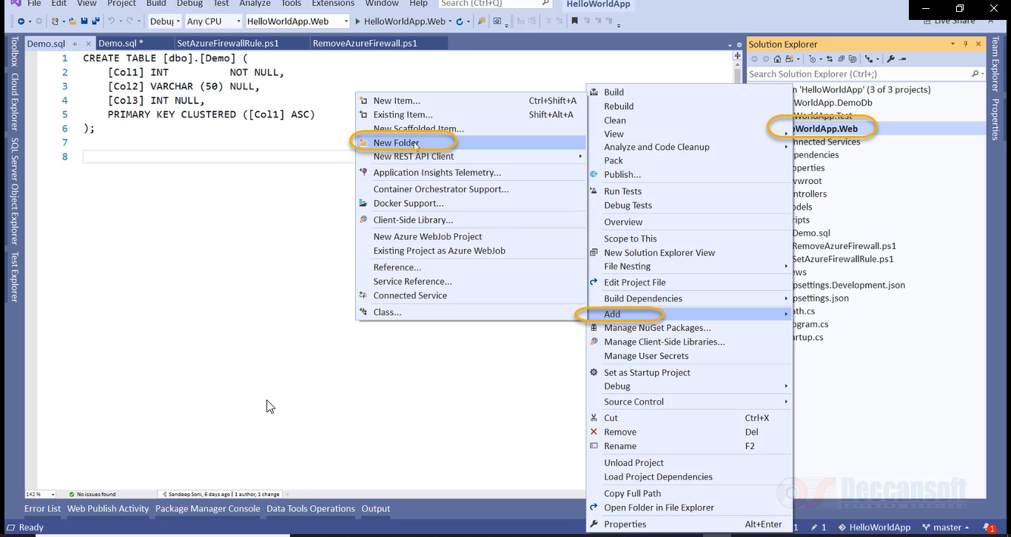

Add new folder terraform templates to the project

Add the new file to it

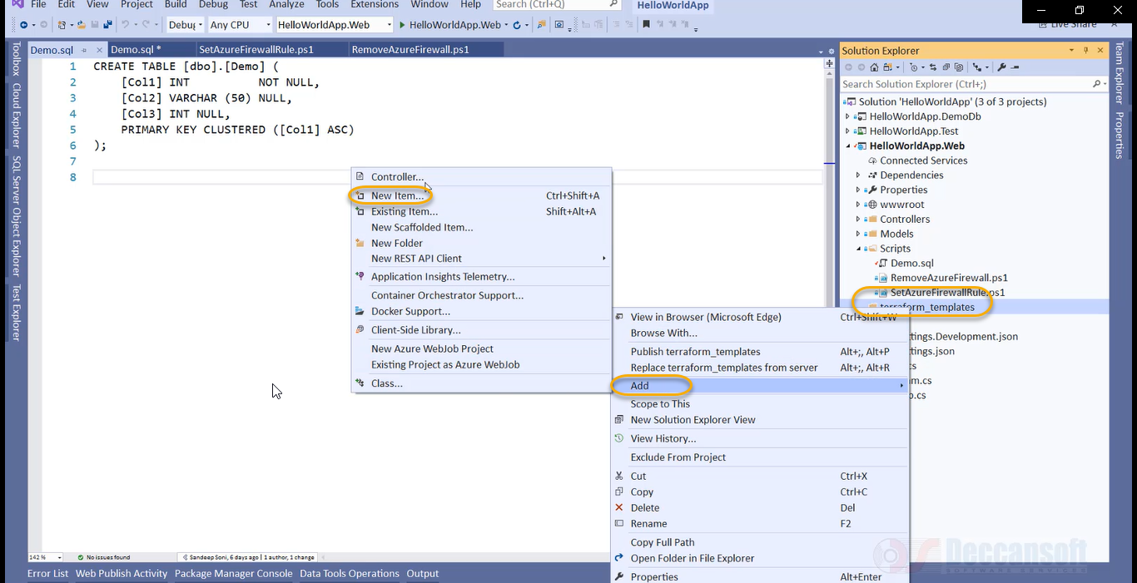

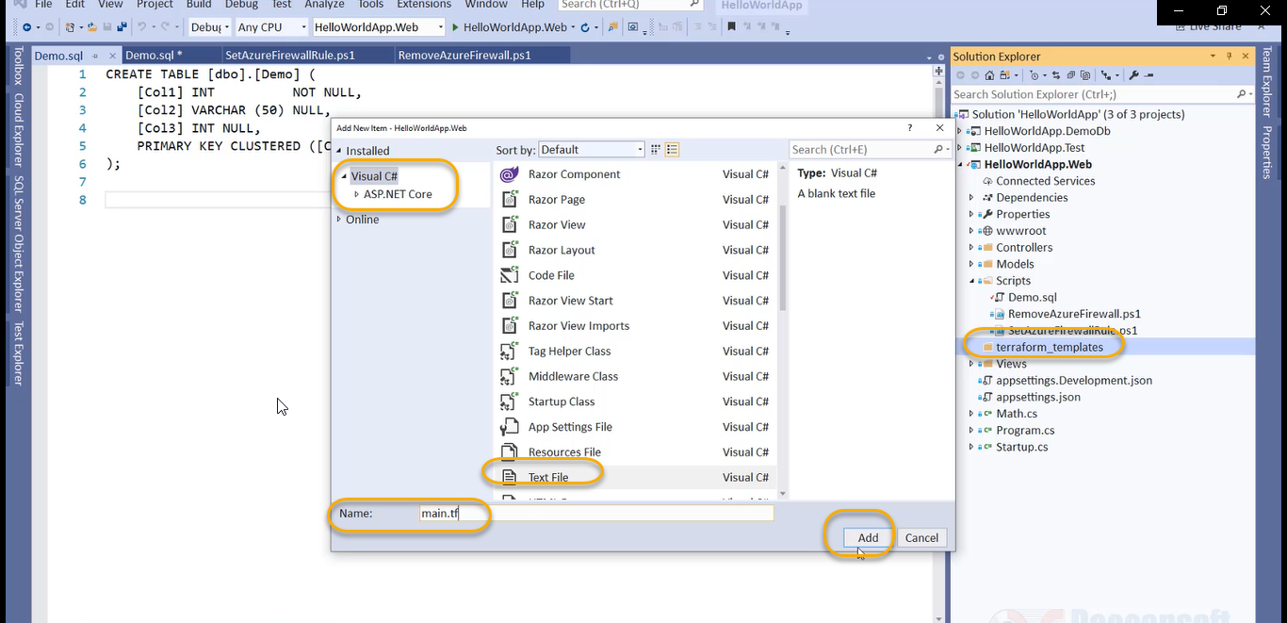

In the main.tf paste the code and save it

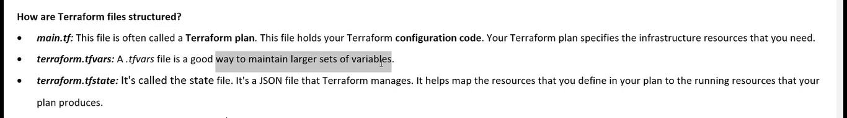

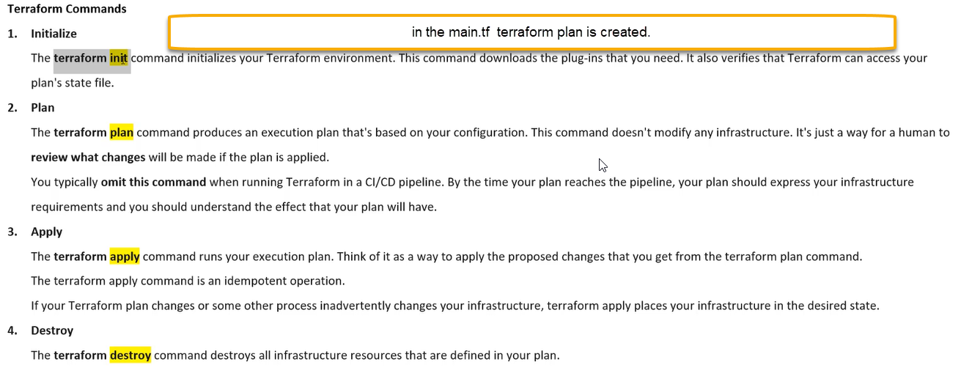

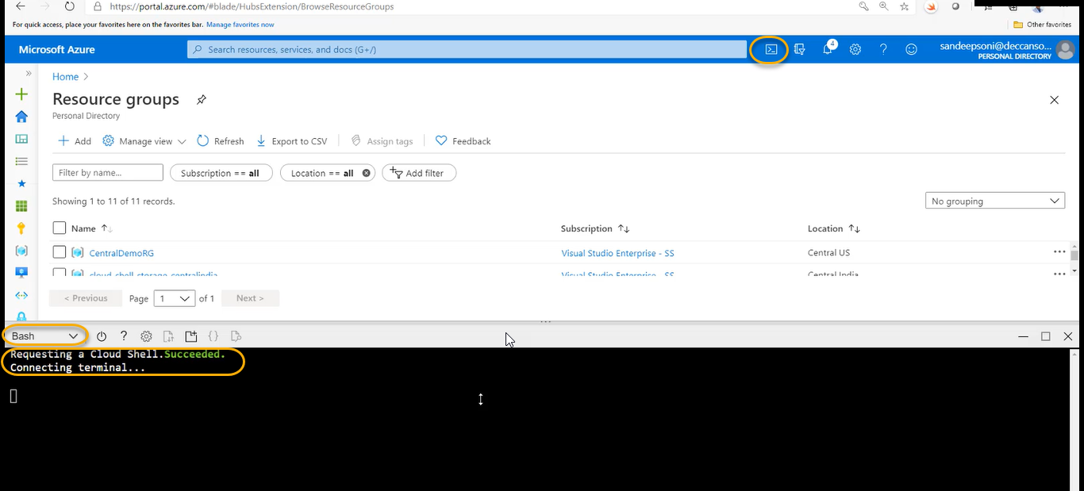

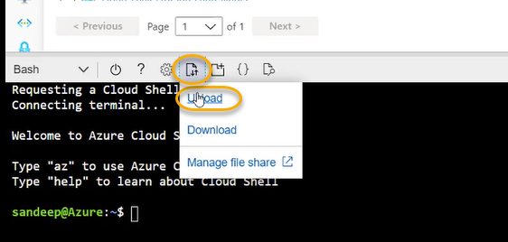

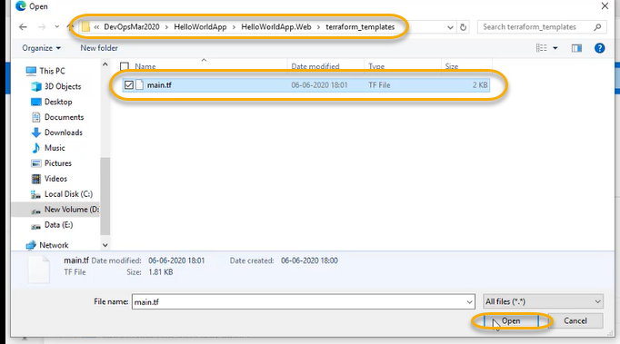

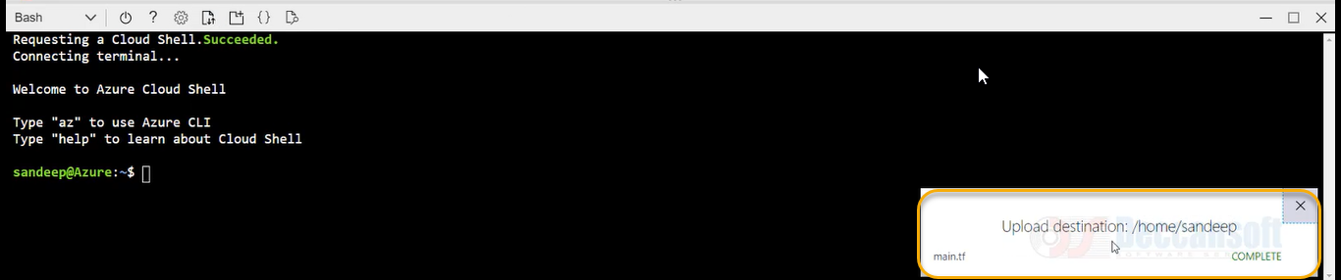

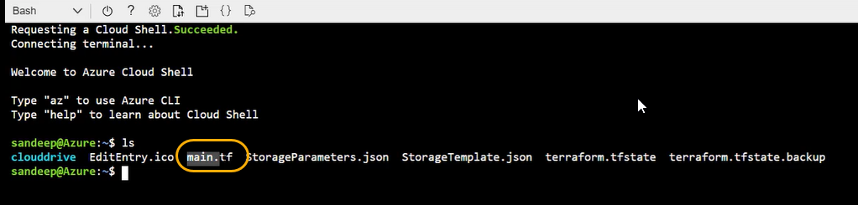

clear

if you want to paste it right click on it

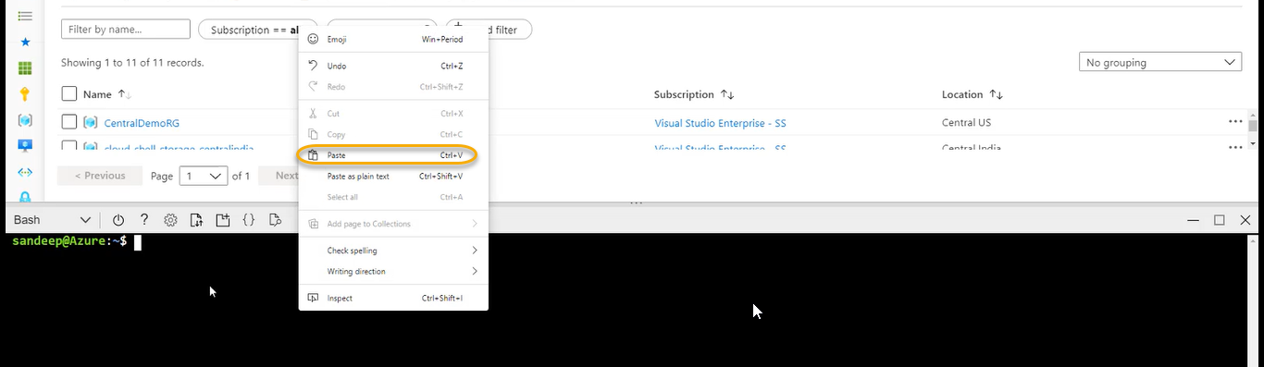

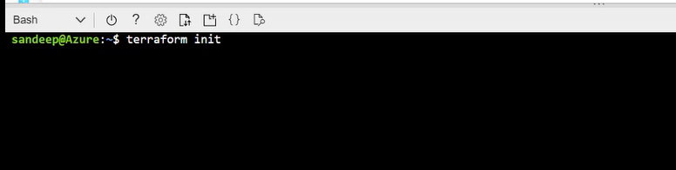

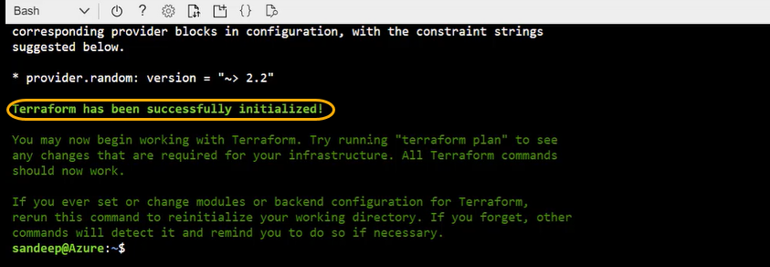

Now execute the terraform plan it is like a preview what are the steps it is going to execute/create

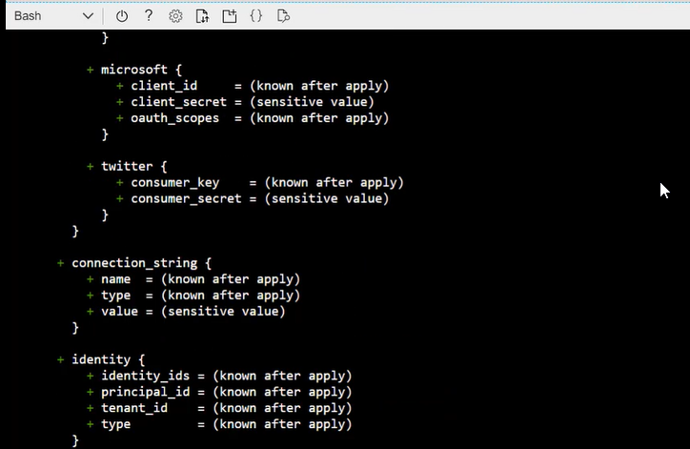

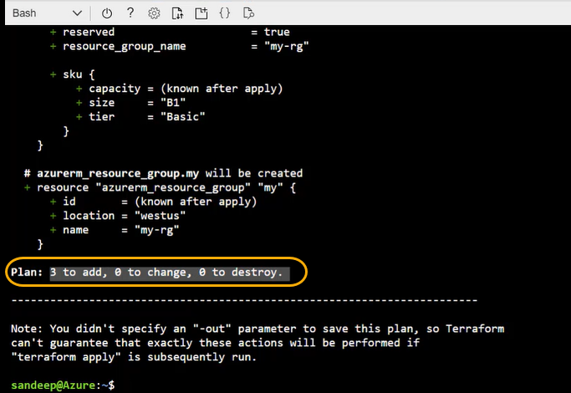

Click on terraform apply

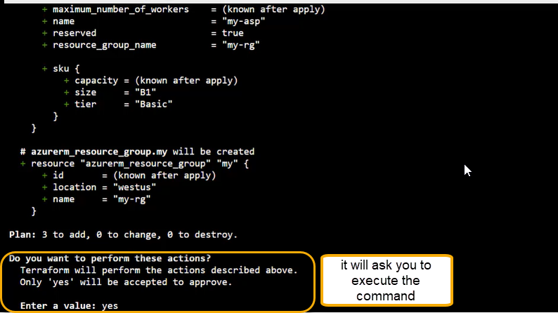

Click on Yes

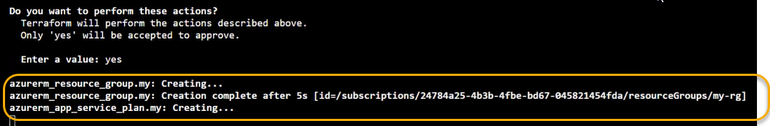

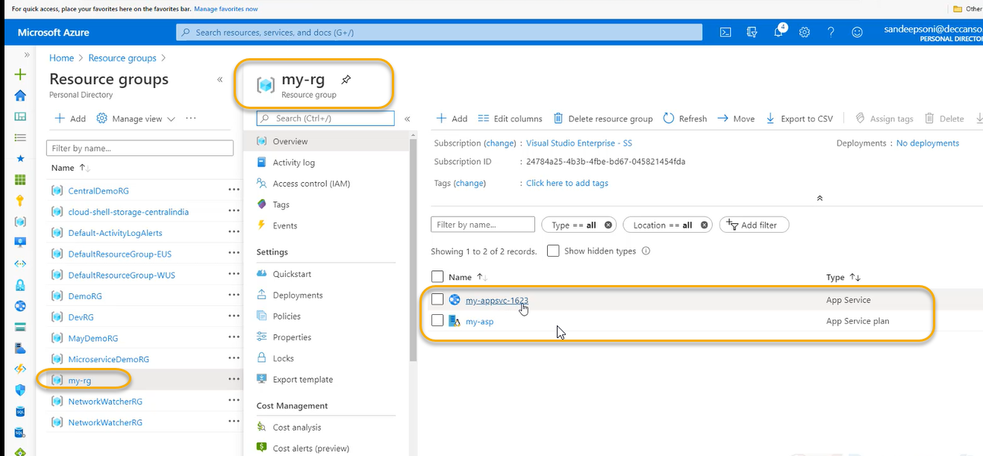

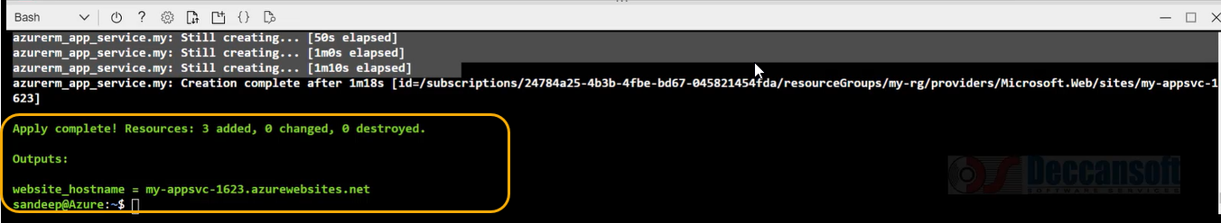

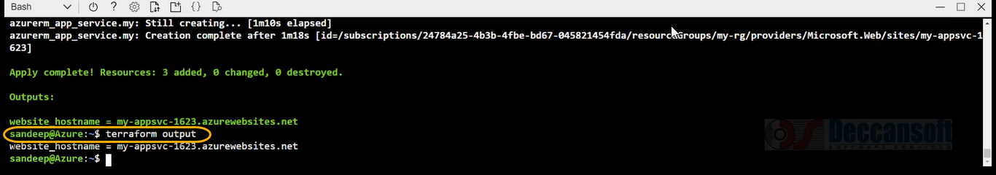

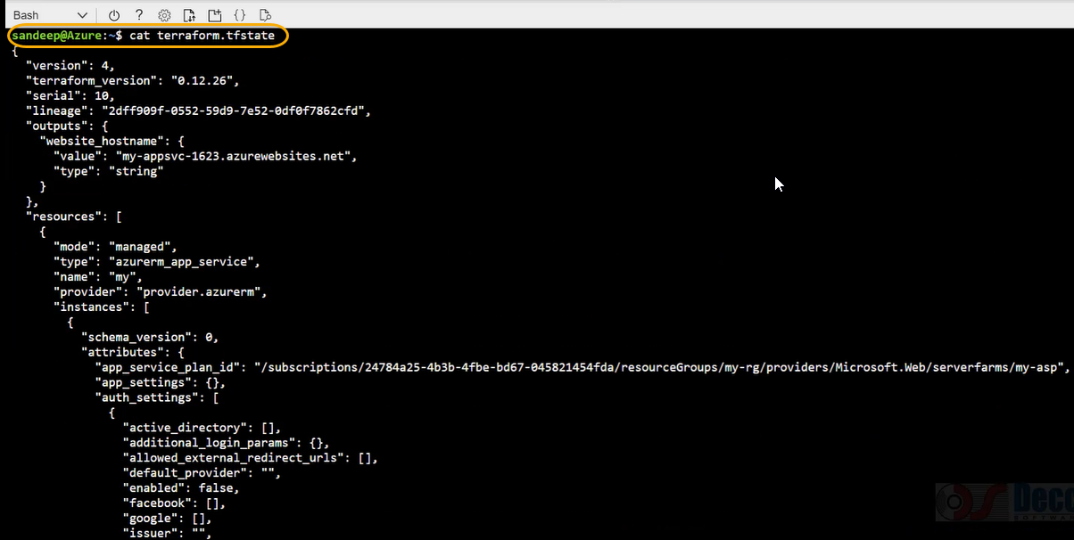

terraform show

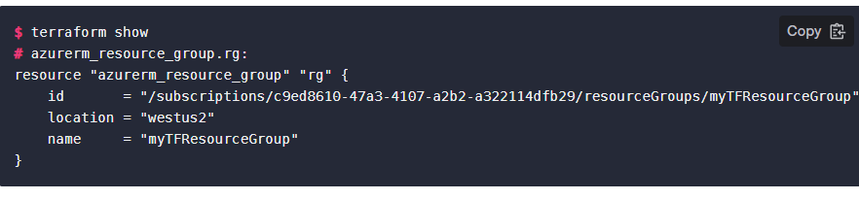

terraform list

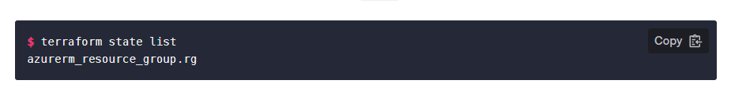

Change Infrastructure (<https://learn.hashicorp.com/tutorials/terraform/azure-change?in=terraform/azure-get-started>)

If you do any changes to configuration for the previous main.tf file/infrastructure ( previously we have not added environment and teams)

terraform plan -out=new plan

terraform apply “new plan”

terraform show

terraform destroy: to remove infrastructure from your Azure cloud account.

terraform depends_on: we see the dependencies that are not visible in terraform

for creating the VM we need the resources like resource group, Virtual network, subnet, network security group and network interface card

Download the terraform from hclterraform website and set the environment varaibles

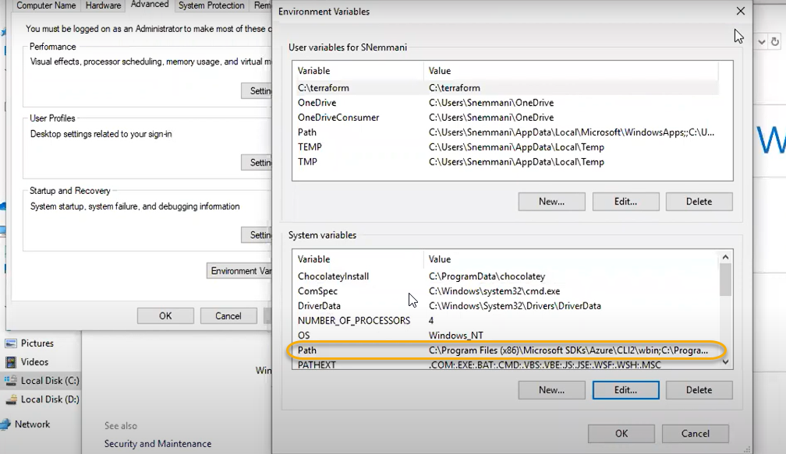

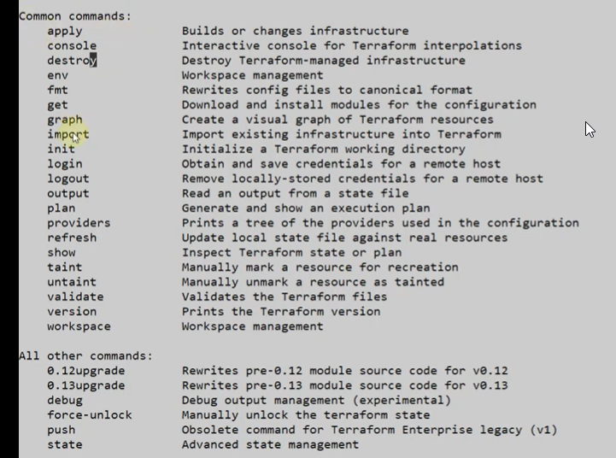

Init: if there are any plugins is there it will download from internet (related to provider like aws and azure) and in locally it will store the provider plugin

Plan: it will show the blueprint of your plan in the instances which are creating we can see here or dry run

terraform validate if your code does not have errors and your syntax is good then it will show the success



If there are any errors, it will show the line number

terraform apply

it will execute the config file and create the resources

terraform apply --auto-approve a pop will not come for yes or no it will be autoapproved

if we are running in locally we can see terraform.tfstate (main.tf related code we can see in terraform.tfstate). Typically we can store the terraform.tfsate file in storage account > blob containers which is called remote backend process.

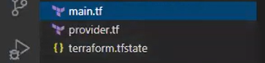

output: read an output from state file

terraform destroy: it will delete the file locally which we have ( main.tf)

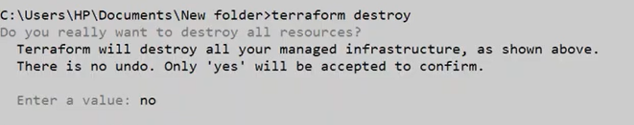

Terraform fmt (the config files are arranged in proper format)

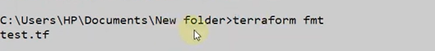

terraform env/terraform workspace

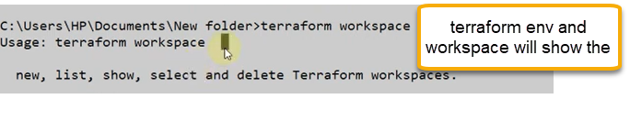

terraform workspace list and if you want to create terraform workspace new dev

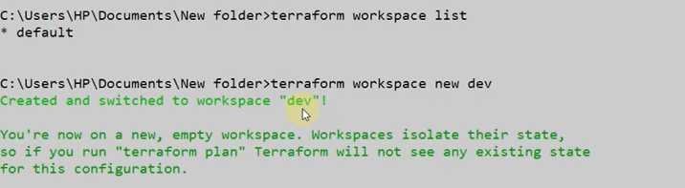

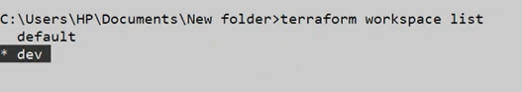

terraform workspace select default

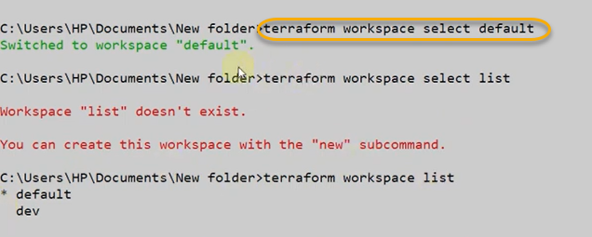

terraform show it will show what are the tstate files present locally we can see in cmd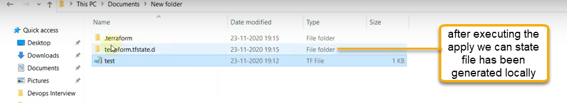

manual created service if you want to bring to terraform, we can use import

terraform version

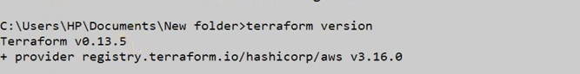

If you want to upgrade to any version (if organization is using the old version if you want to upgrade to latest)

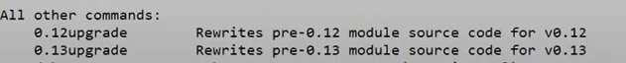

terraform graph shows the terraform in a graphically way

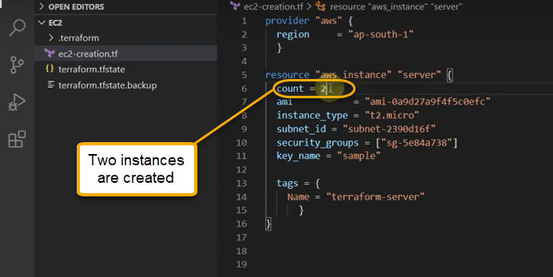

Terraform variables: Input and output

Input: Within the code (.tf) we can define the variables

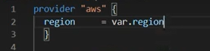

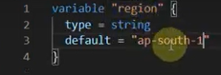

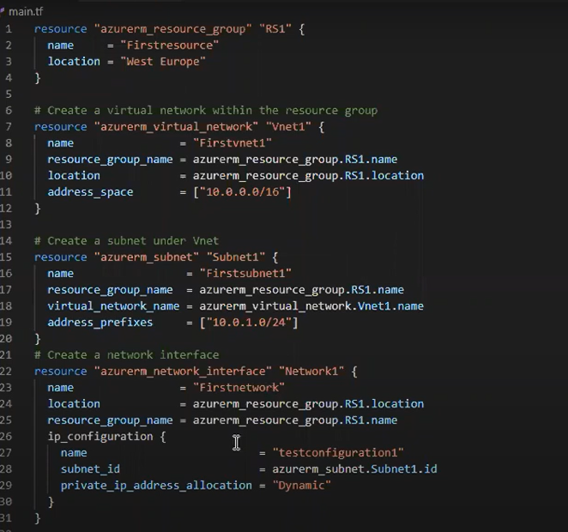

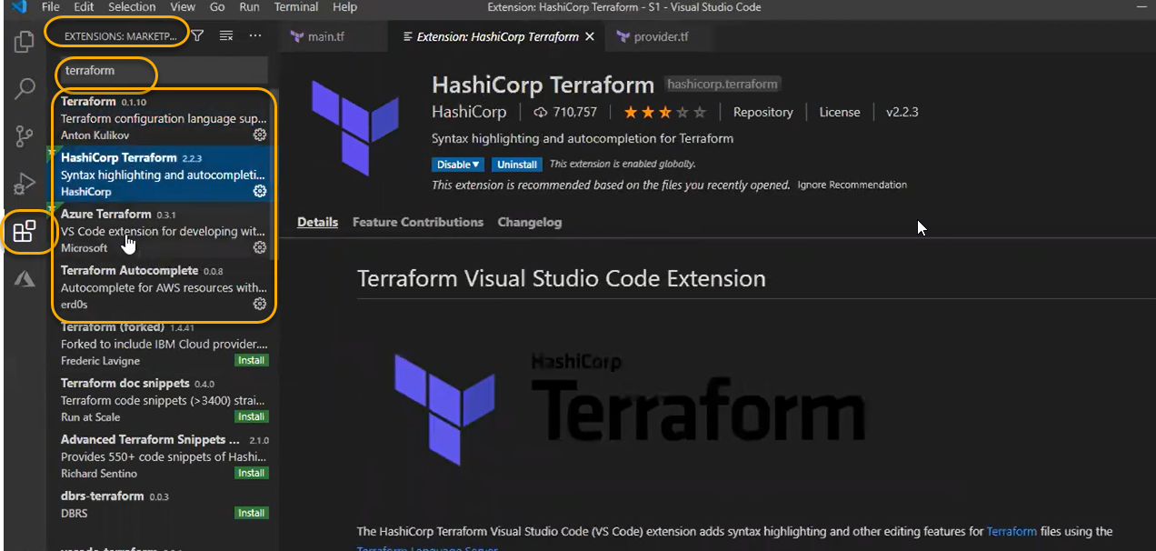

Resource = “resource key name” , azurerm( azure resource manager ), “name”

resource = ‘’azurerm_resource_group” “RS1”

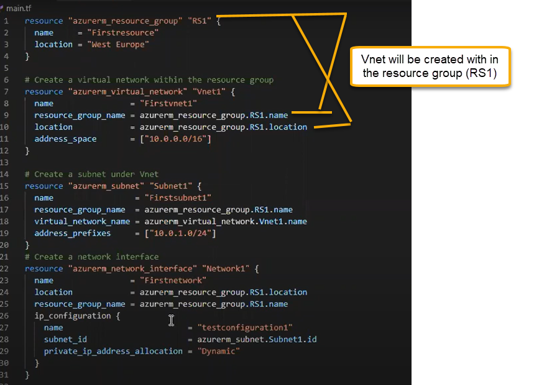

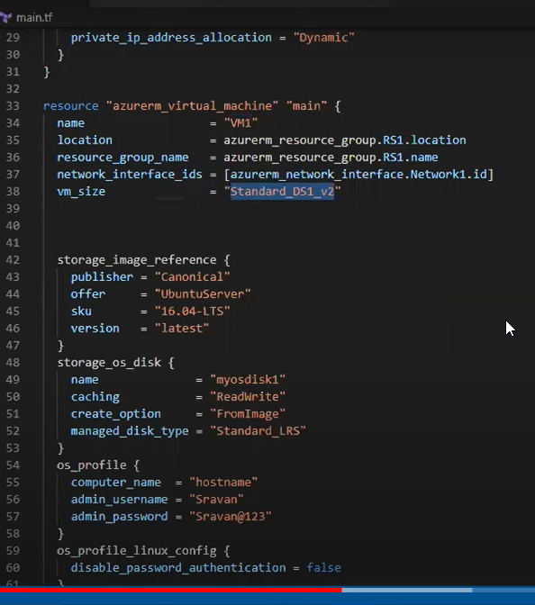

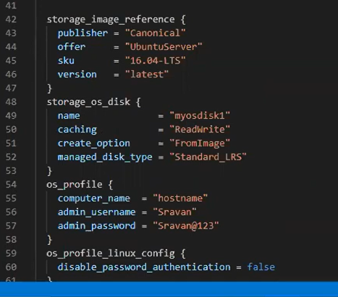

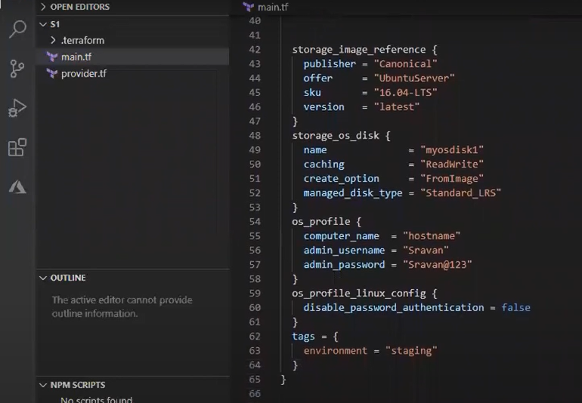

Now we need subscription id, tenant id and client id

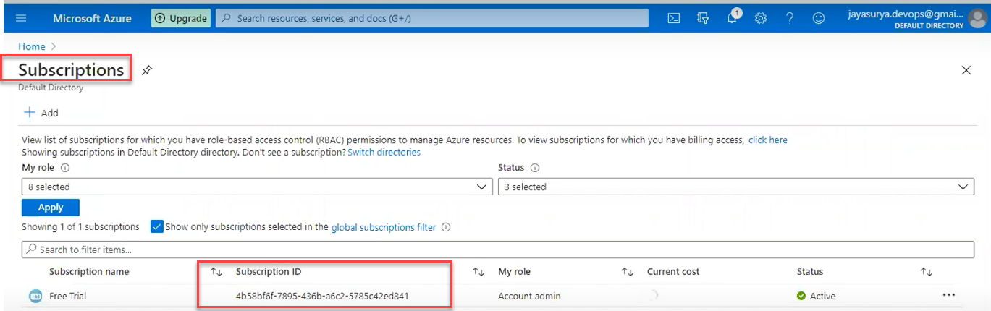

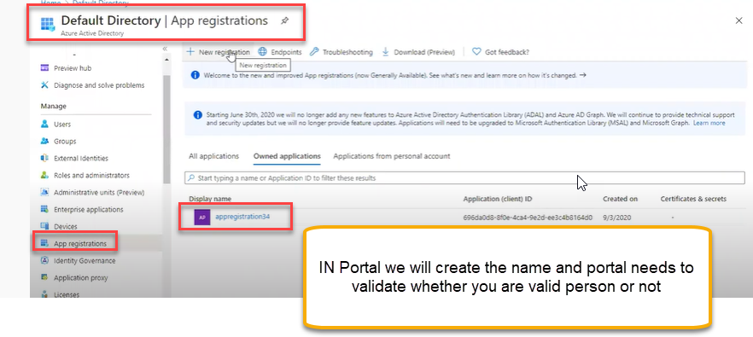

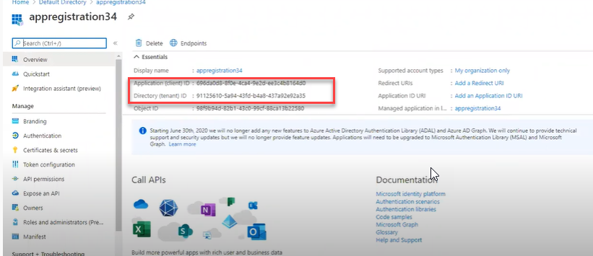

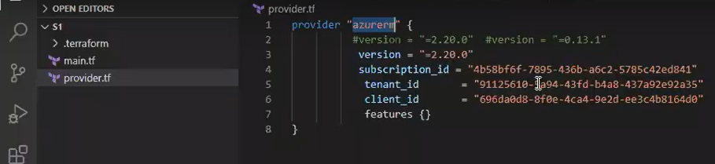

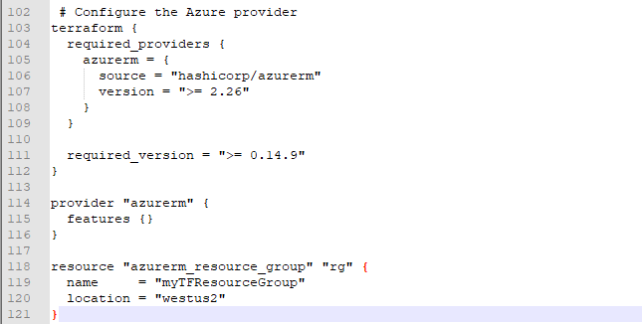

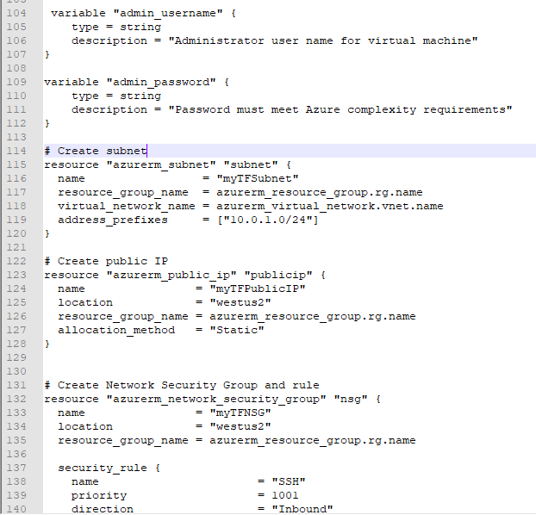

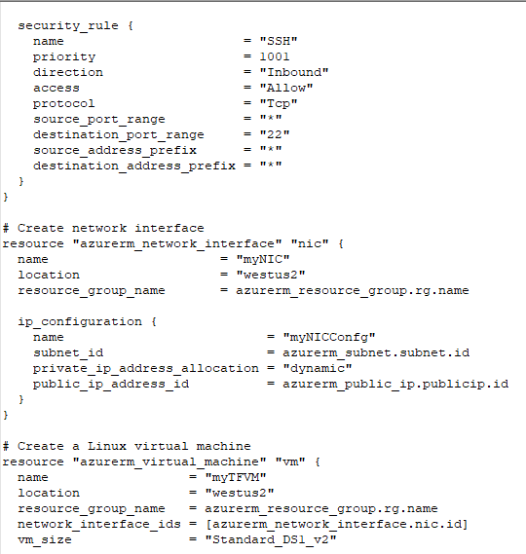

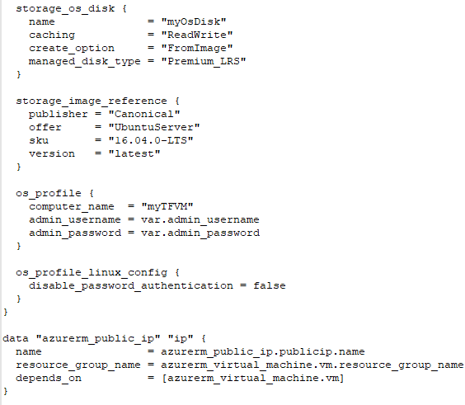

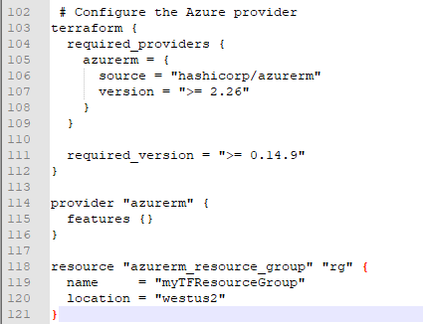

If you click on terraform apply

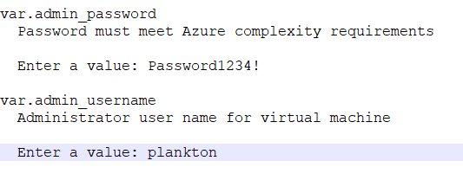

To communicate the Azure with terraform follow the below steps

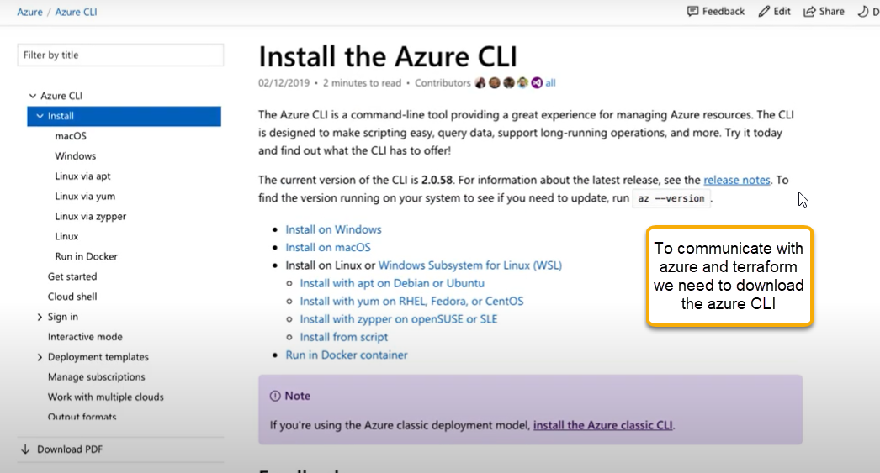

Run the command

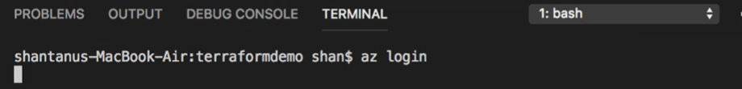

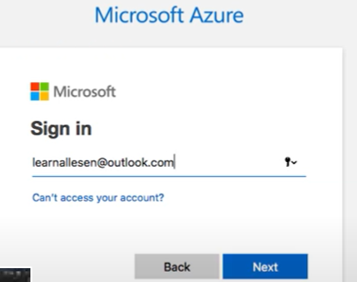

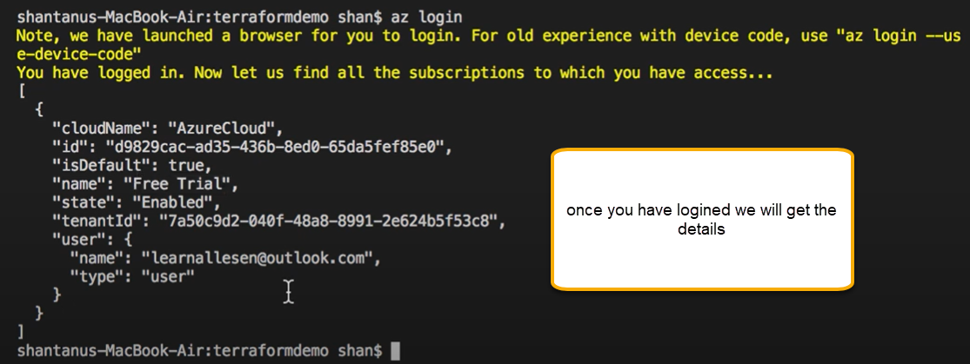

<https://docs.microsoft.com/en-us/azure/developer/terraform/>

<https://registry.terraform.io/providers/hashicorp/azurerm/latest/docs>

<https://docs.microsoft.com/en-us/azure/developer/terraform/create-linux-virtual-machine-with-infrastructure>



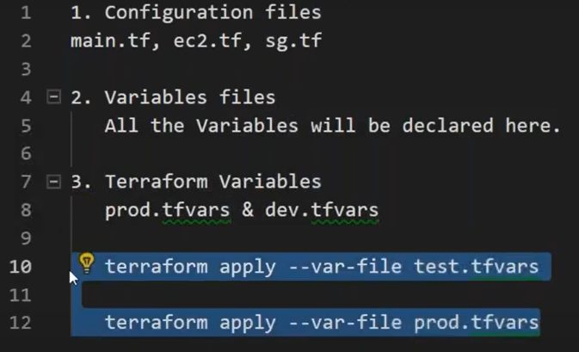

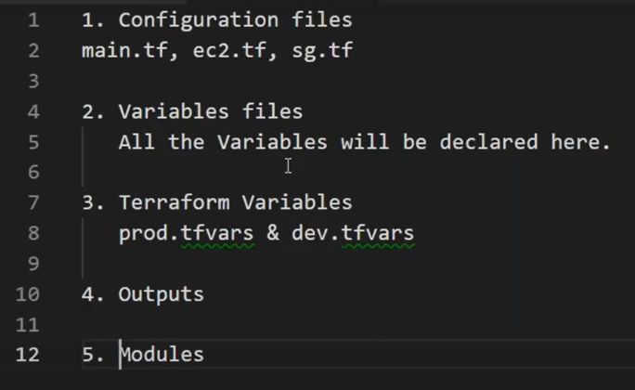

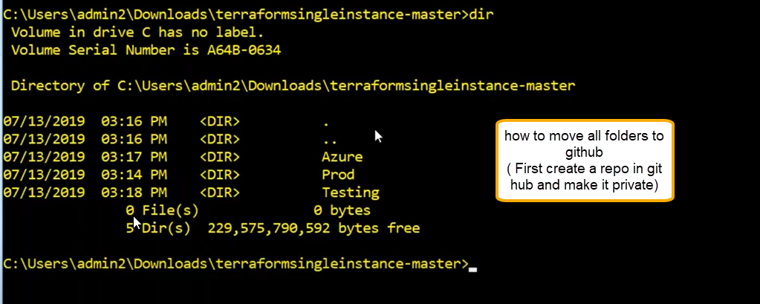

git init

git status

git add.

git commit -m “ done editing”

git remote add origin

git push origin master

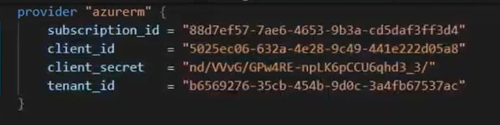

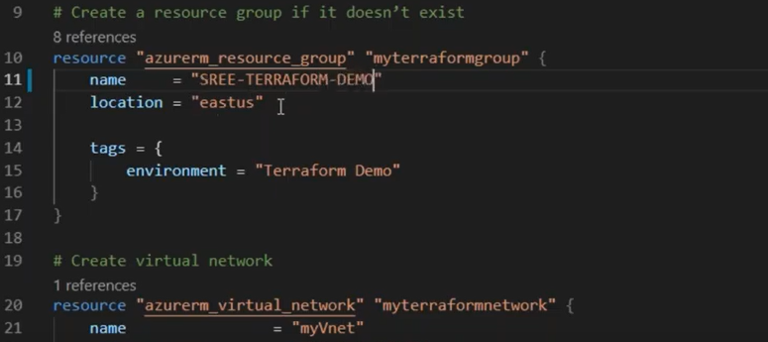

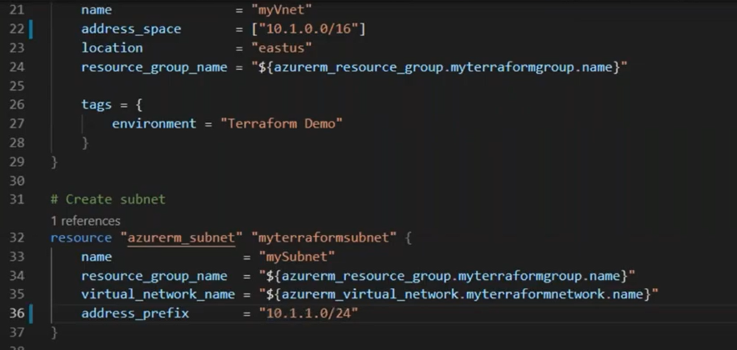

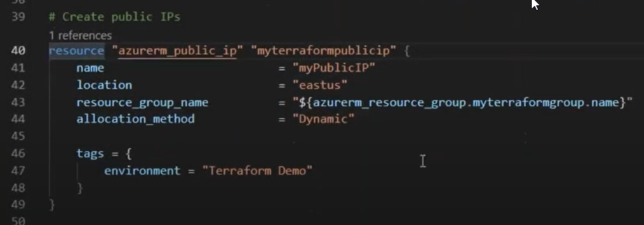

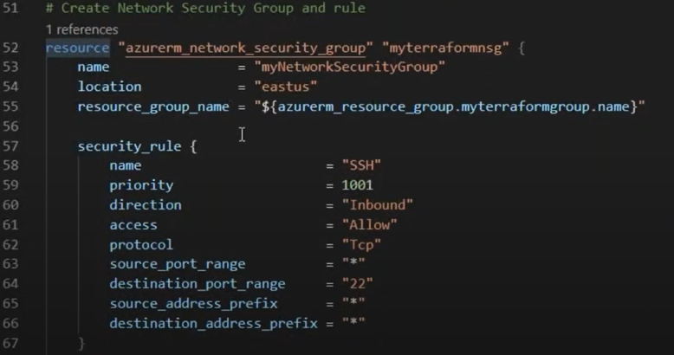

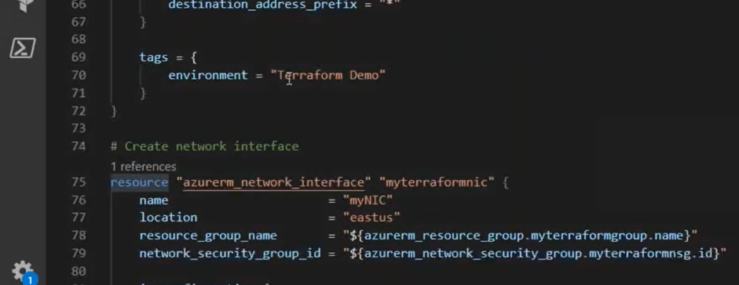

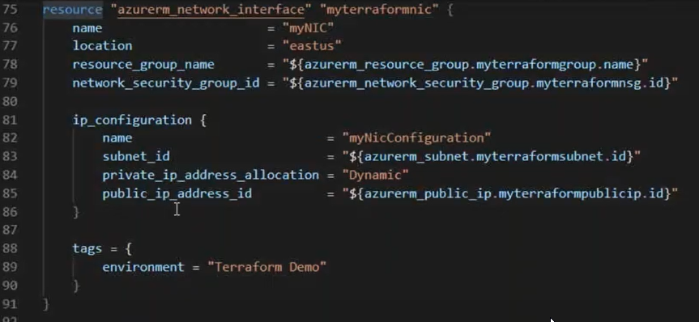

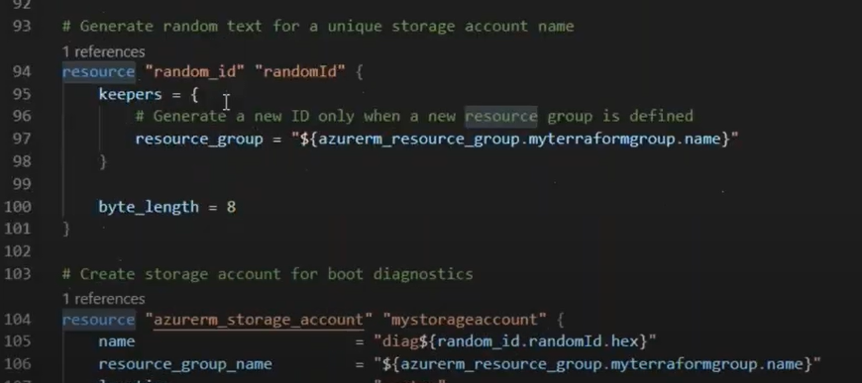

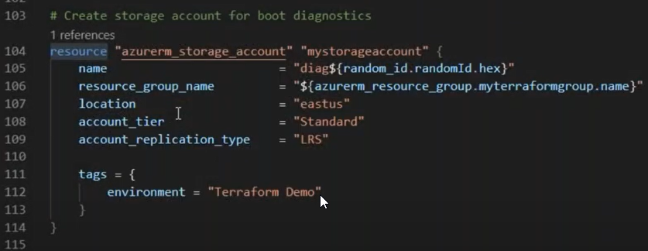

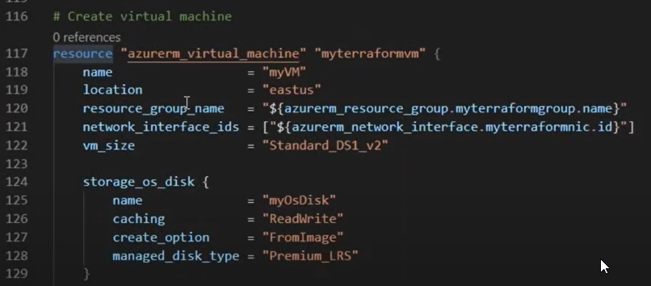

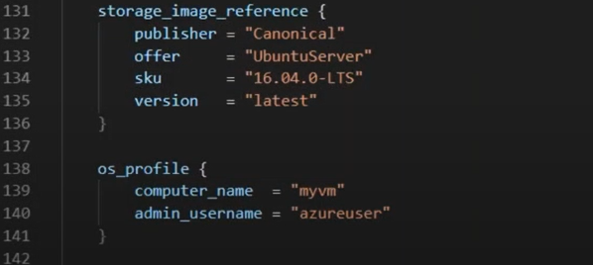

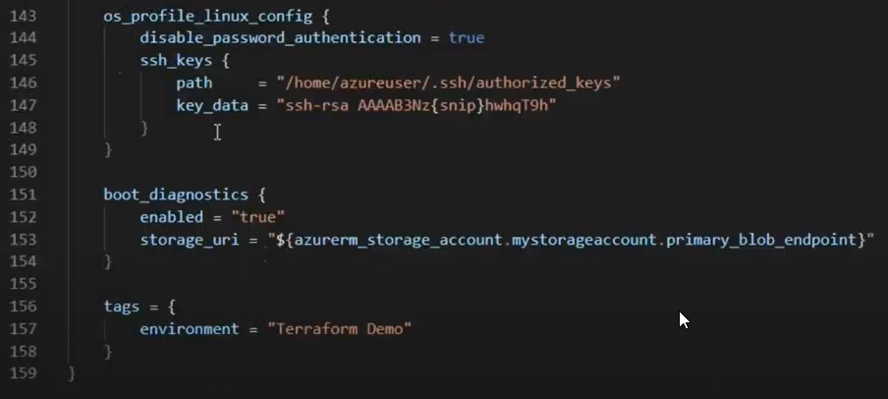

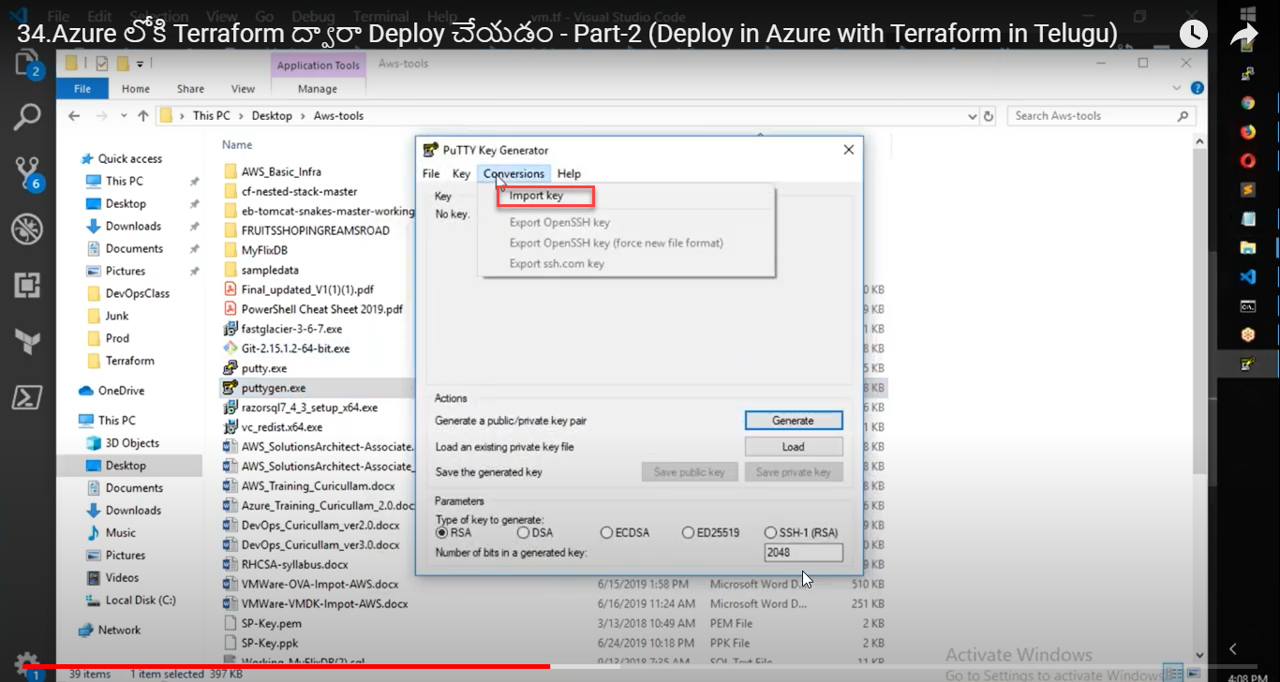

Copy the key data and paste it in the 147th line

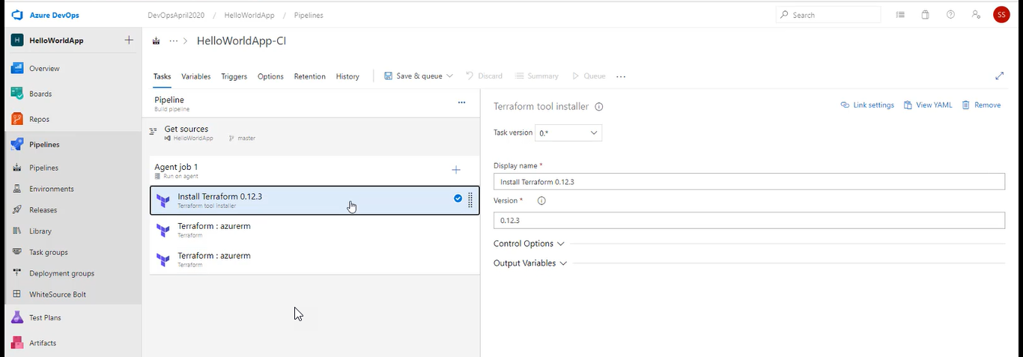

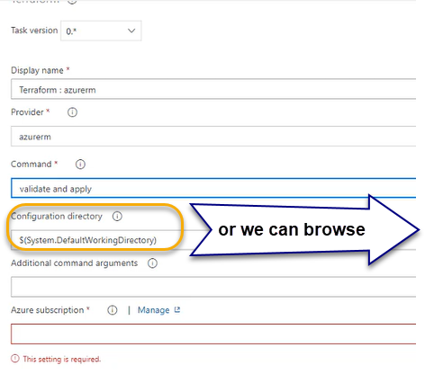

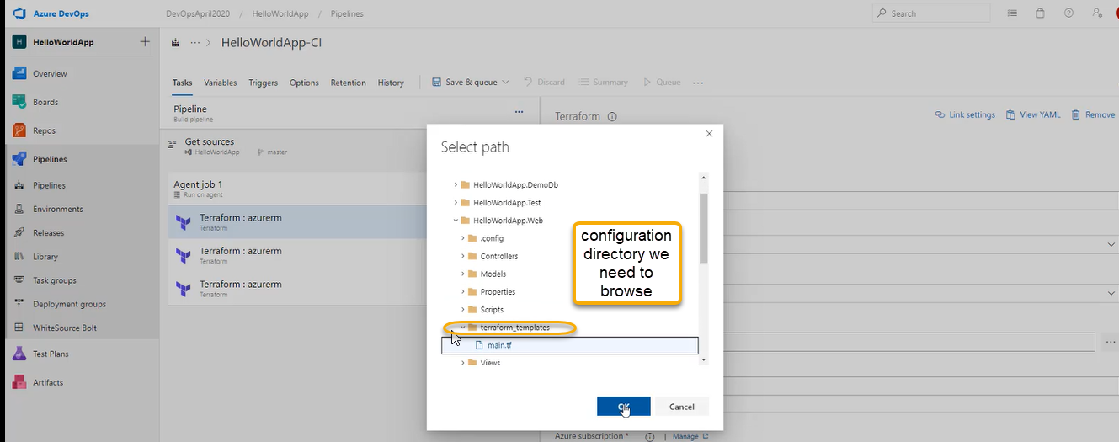

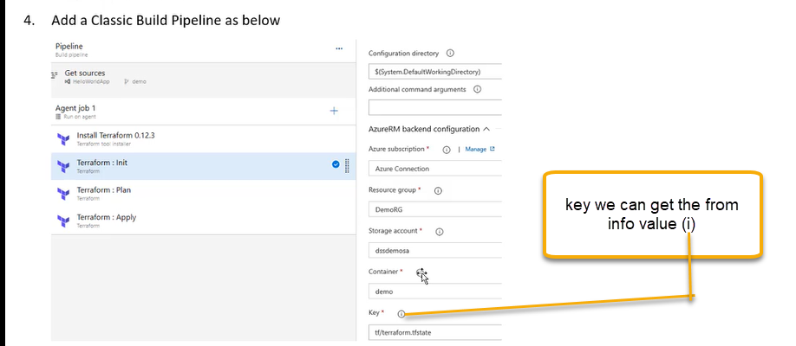

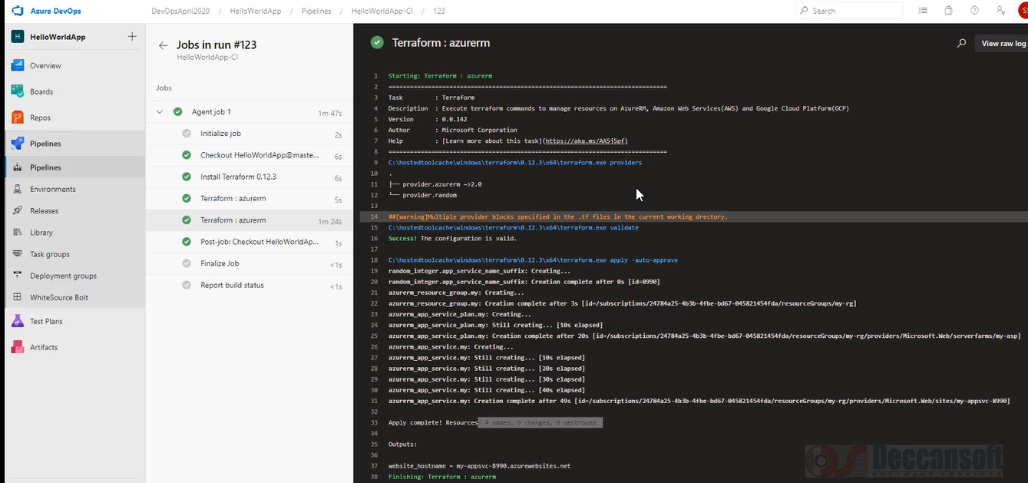

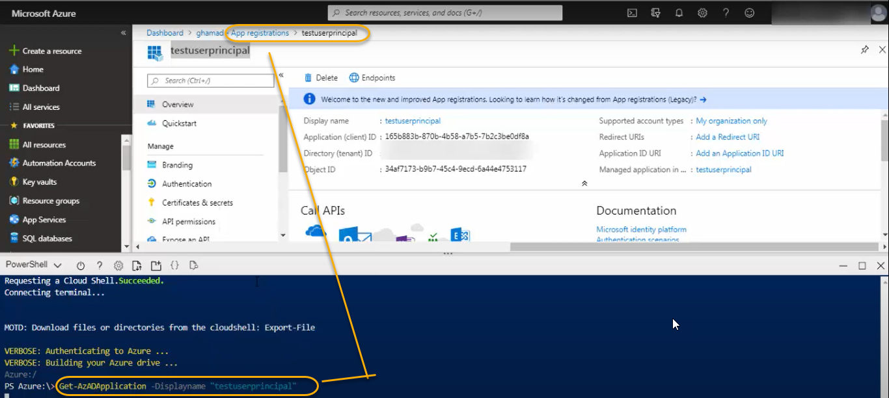

Get-AzADApplication -Displayname “app registration name”

Get-AzADServiceprincipal -Searchstring “app registration name”

When ever app registration happens there are 2 objects created one is application object under app registration and service principal object which is under enterprise application